THE NOTABLE KITTY LABATT JARVIS BLAIR

I was born in Toronto but moved at 3 weeks of age to New York City as my dad was sent down from Toronto as a partner to open McLeod, Young and Weir, a Canadian securities firm dealing in bonds. He set up in the offices of First Boston Corp. First Boston helped him in the USA and he helped First Boston with Canadian stocks.

Mother (Margaret Biddulph Scatcherd) died when I was 9 of a cerebral hemorrhage at the age of 44. I attended Brearley School in New York and then went to boarding school in Virginia and graduated from the Madeira School which was in McLean.

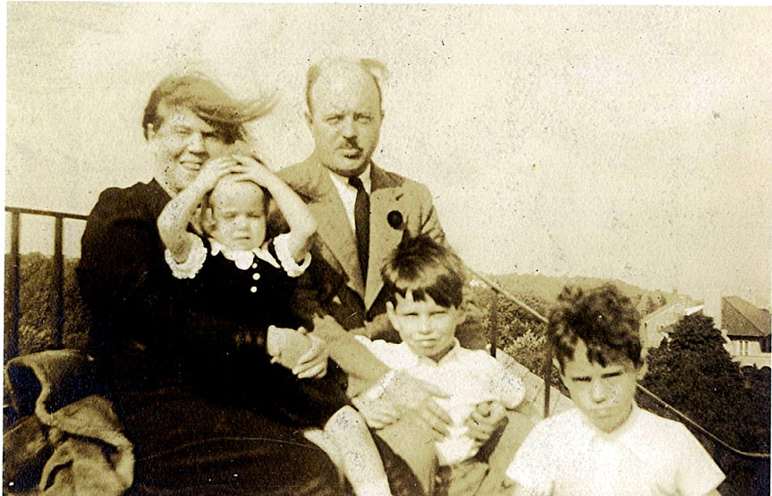
Our author pulls her windblown hair out of her face in 1937.

After junior college I went to work as social secretary to I.S.V. Patcevich, the C.E.O. and President of Conde Nast Publications (Vogue, Glamour, House and Garden magazines). I met my first husband, Daniel Wann at Vogue. He was an architectural photographer who was born and worked in Paris, France. His mother was married to Herman Livingston Rogers who was best man at the wedding of Wallis Simpson to the Duke of Windsor. The Duke (King Edward) was Herman's best friend and he abdicated the Throne of England for Wallis. We were married for 6 years and had 3 absolutely fabulous children, Alan, Barbara and Christopher.

When we divorced, I moved myself and the children to Toronto as I did not want to be a single mom in New York City with 3 children under the age of six. I reacquainted myself with my Canadian family which turned out to be one of the best decisions I ever made. But after living in New York, Toronto was like the far side of the moon!!!! I was just about to move back to New York, 3 kids and all, when I met my present husband Stan Blair (another one of my good decisions)

Sadly, my eldest son Alan, named after my brother Alan, drowned in the Don River in 1965 and it took me a very long time to get over it, but passing time DOES help to heal the wounds and eventually Stan and I had another child named Katharine Labatt Blair, named after Kitty Scatcherd. She is totally addicted to Family Genealogy and has a wall covered in her home with pictures of John Labatt Scatcherd and the Bar from his Military Cross. She also has collected Labatt ashtrays and memorabilia as she goes to antique fairs and collects anything she can get her hands on that says Labatt or is family!!

I now live at Palace Place in Toronto, a skyscraper condo complex overlooking beautiful Lake Ontario.
______________________________________________________

